Guideline

Admin (Oracle)

1. First of all, admin has to log in from the Oracle application as an admin.

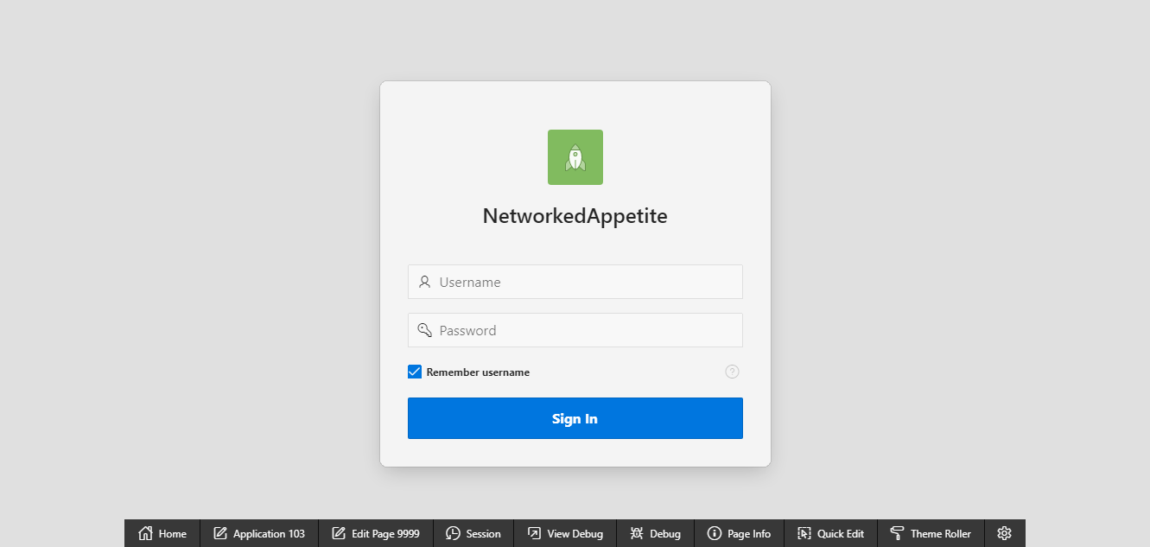

2.An admin can overlook over trader’s added product.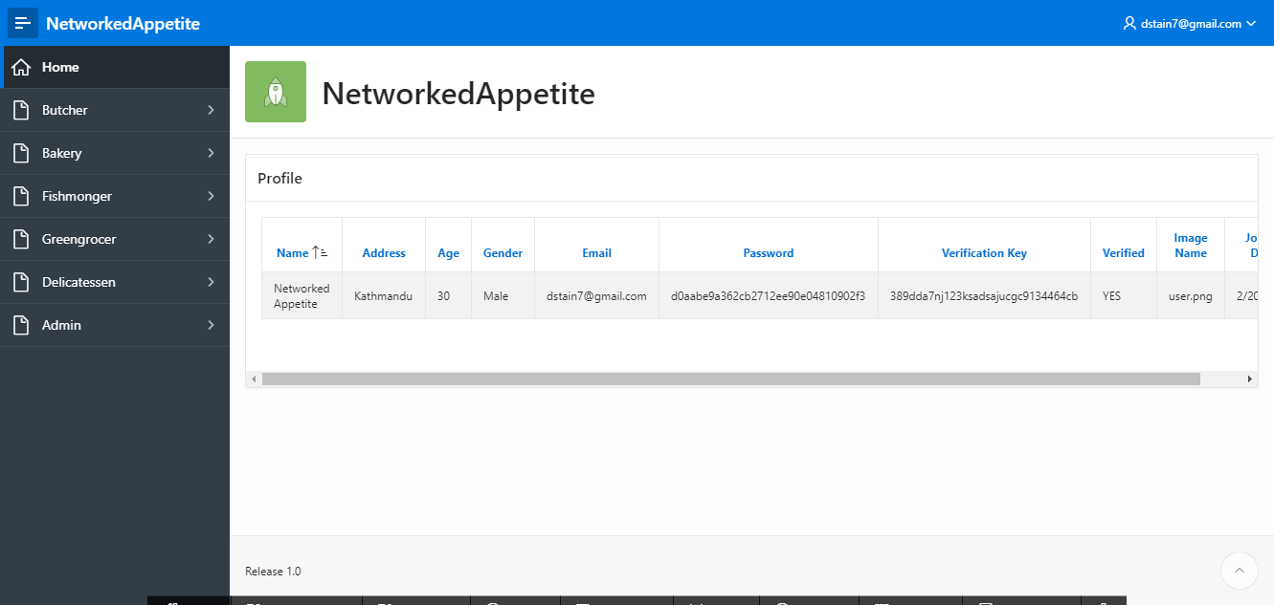

An Admin can see customer’s activity like my cart, payment method and so on.

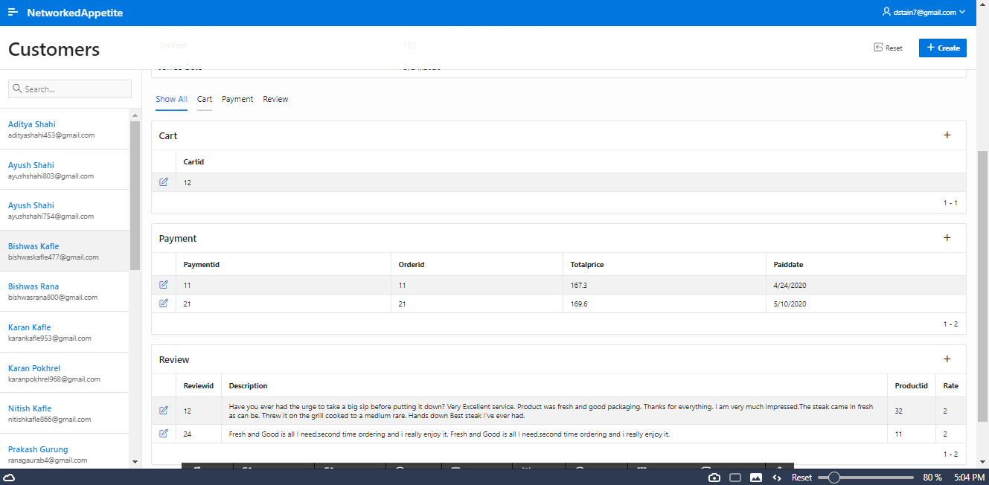

3.An Admin can also look over customer details and also can see number of customer registered.

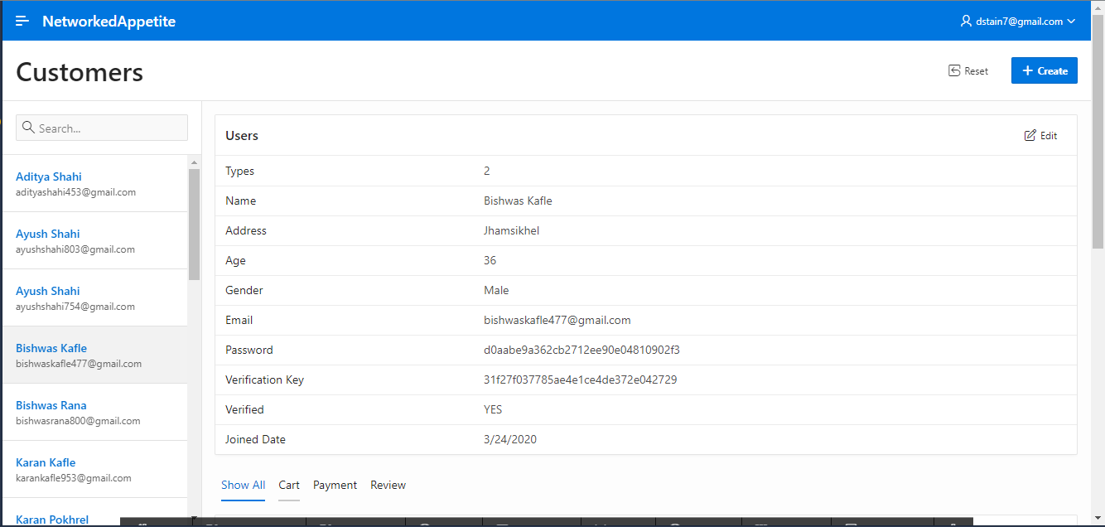

4.An Admin is capable to watch over trader’s product and also can delete the product if he/she tries to violet uniqueness of each other.

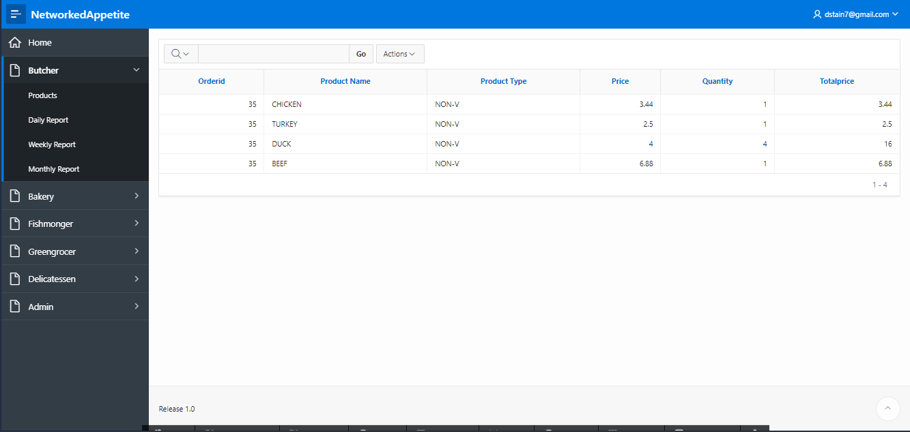

5. An admin can also look over trader’s details as well as product details as well as can overlook over sales details through dashboard.

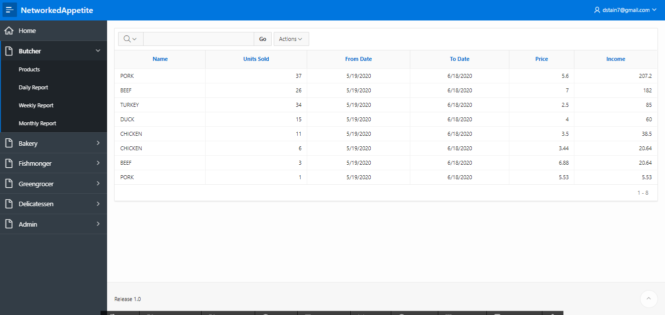

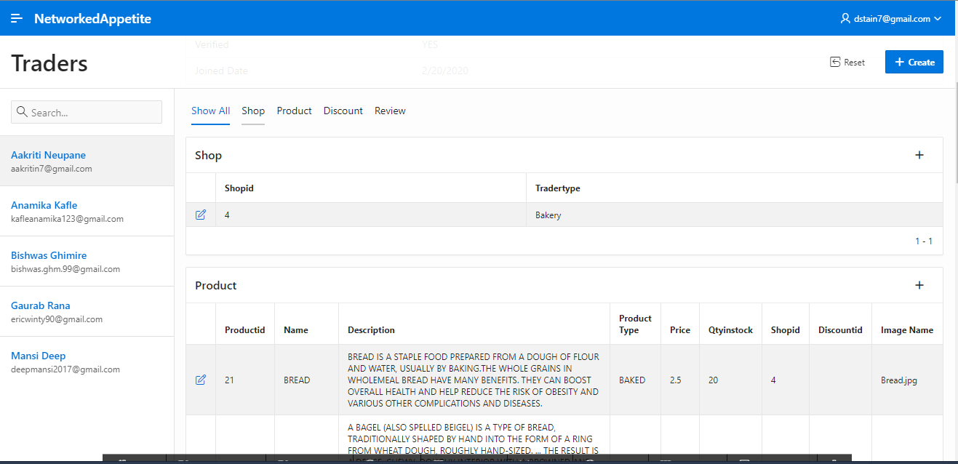

Trader’s details

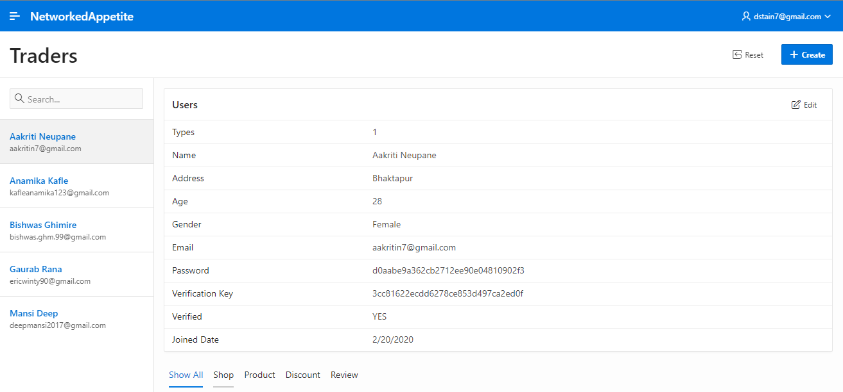

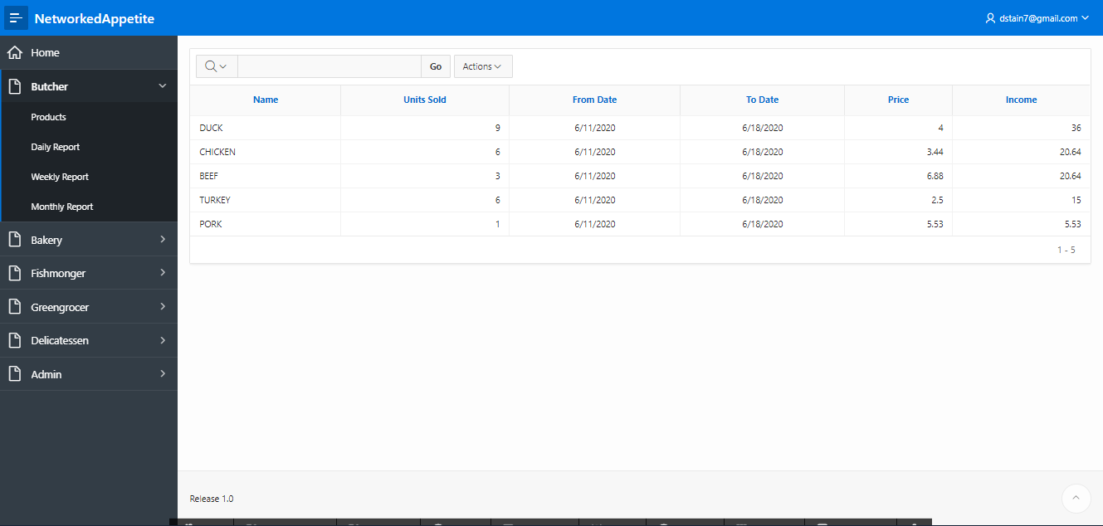

Dashboard of an admin to know the sales report of all traders overall.

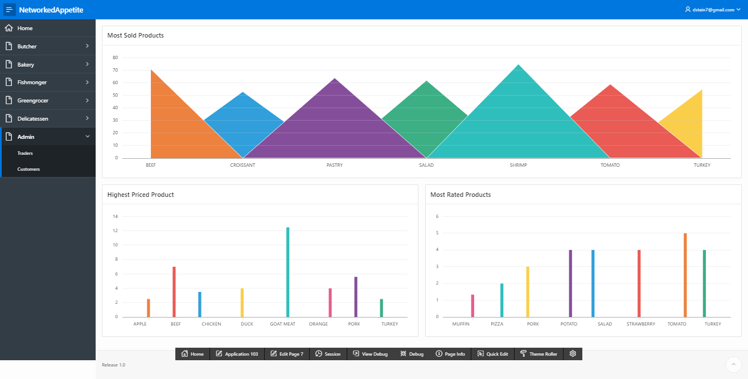

6. Logout

Admin can log out of this page from sign out button in the top right corner of the page.

